**ELASTIC IP & ADDING MORE VOLUMES:**

**What is elastic IP?.**

Elastic IP is mapping static IP(unique IP) address to your ec2 instance. By default when you create EC2 instance, Amazon will assign dynamic IP(change when you reboot the ec2 instance).When you require static IP for your instance in that case you can choose Elastic IP.

To use an Elastic IP address, you first allocate one to your account, and then associate it with your instance or a network interface. To ensure efficient use of Elastic IP addresses, we impose a small hourly charge if an Elastic IP address is not associated with a running instance, or if it is associated with a stopped instance or an unattached network interface.

**STEPS TO CREATE ELASTIC IP & ITS MAPPING TO EC2 INSTANCE:**

In this step itself we will see how to add extra volume to your ec2 instance

1.Go to https://aws.amazon.com/console/

2.Enter the credentials

3.Go to service Tab, choose EC2 Instance.

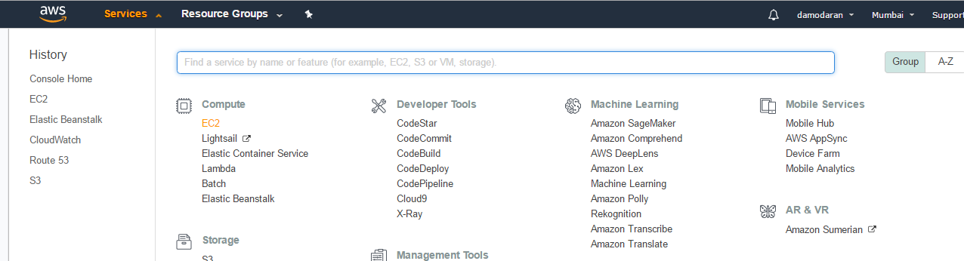

4.Click Launch EC2 Instance button for launching EC2 instance.

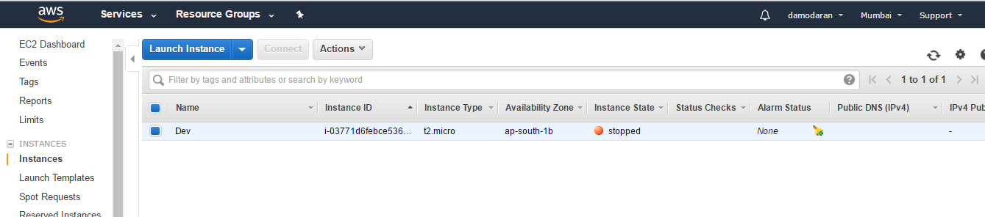

5. Step 1:Choose AMI as per your requirement. You can choose windows/Linux instance which is free tier eligible. Here I am choosing Amazon Linux AMI

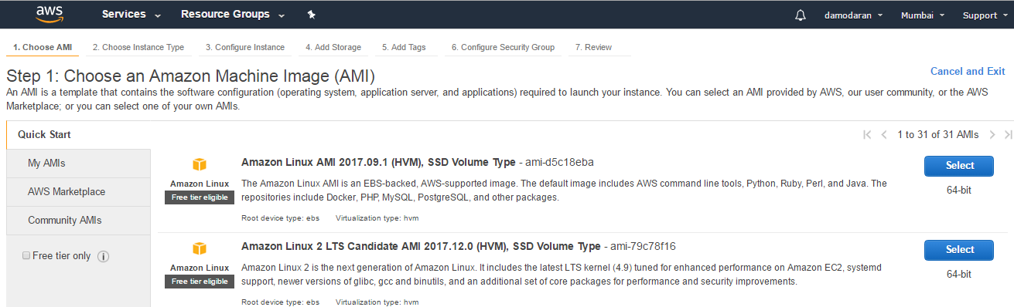

6.Step 2: Choose an Instance Type: We are using free tier account so we can choose only t2.micro instance. So I am choosing T2.micro instance.

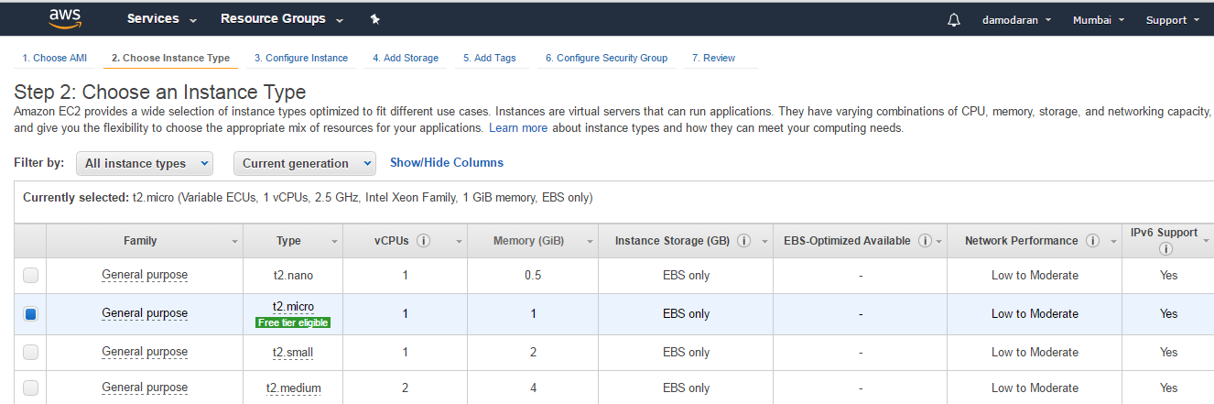

7. Step 3:Configure Instance details : Going to use default configuration like Network, Subnets, IAM role . In this step I am going to disable Public IP, to map elastic IP.

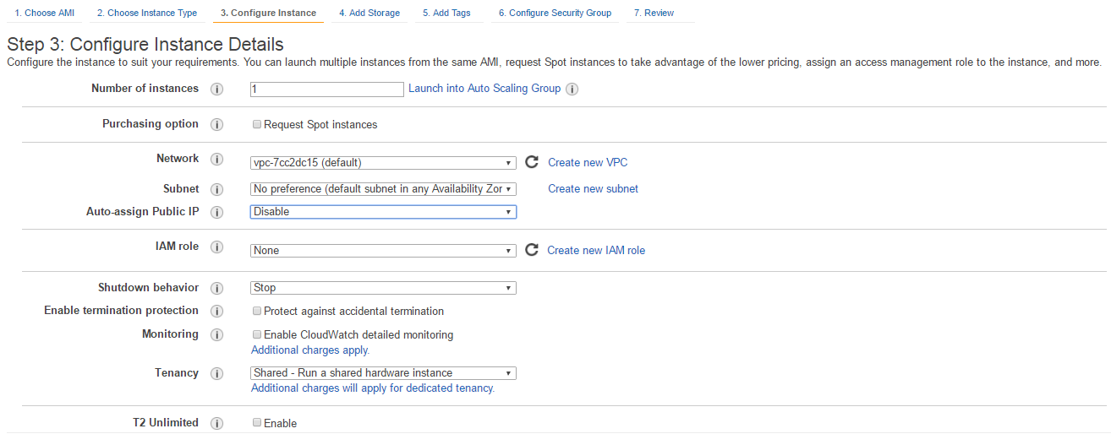

8.Step 4: Add storage: In this step I am going to add extra volume to my EC2instance. Click Add New volume button

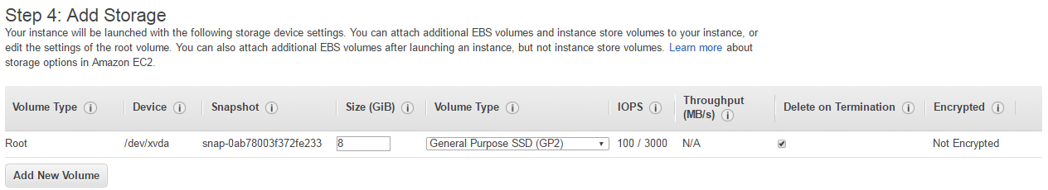

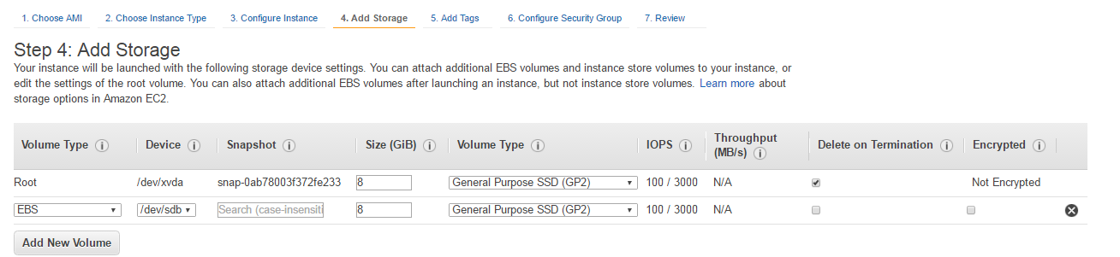

9.Step 5 : Add tags: In this step, give some name for your EC2 Instance.

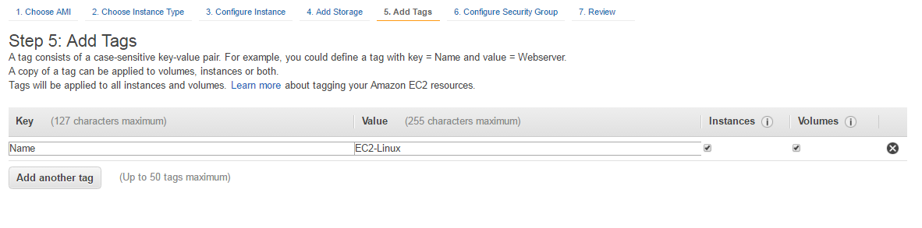

10.Step 6: Security Group: Choose the protocol type by which protocol you are going to access the EC2 Instance. Choose SSH for Linux and RDP for windows(mandatory)

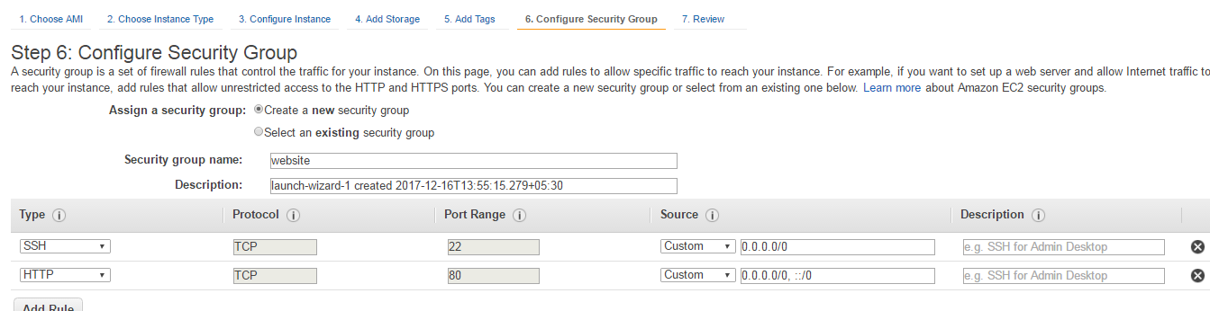

11.Review and Launch.

12.Choose pem file

13.Now you can view your created EC2 instance. Now your EC2 instance doesn't have public IP as we have disabled the auto assign public IP (refer step3)

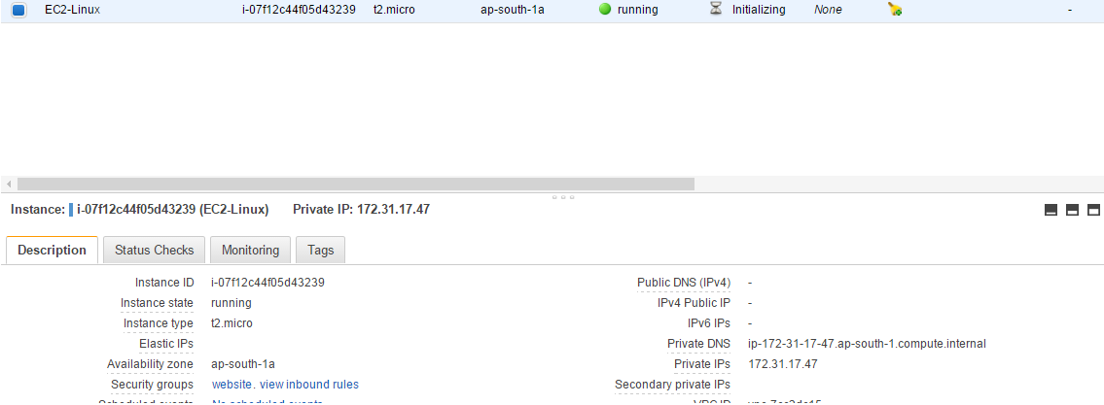

**Mapping Elastic IP to EC2 instance**:

1.In Left side,under Network and Security option you will find Elastic IP option. Click it

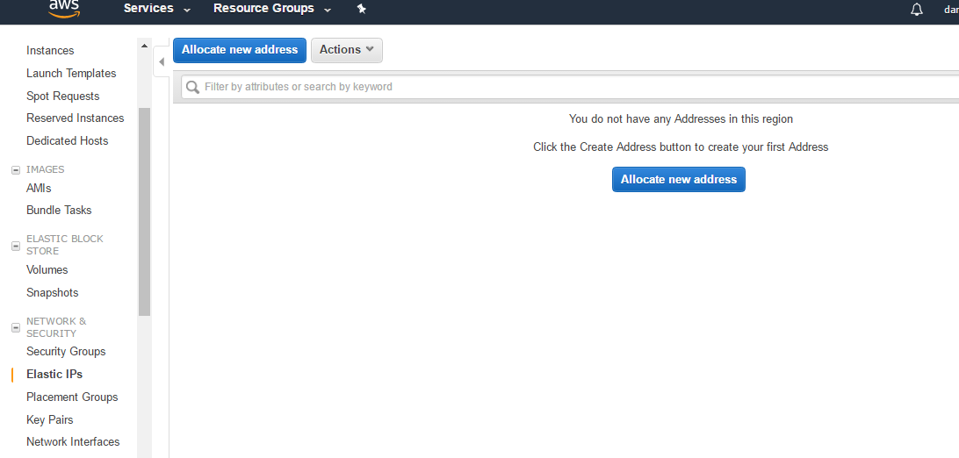

2.Click Allocate New Address button, Amazon will give one dedicated IP to your account as below.

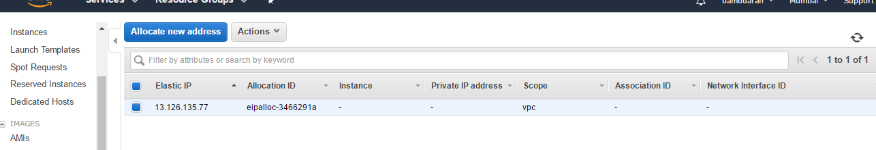

3.Now we need to map this Elastic IP to your ec2 instance. Go to actions, choose associate address and select your ec2 instance. Now you will find elastic ip under Public IP of your ec2 instance.

